**Spike:** 10

**Title:** Game Data Structures

**Author:** Ben Holmes, 103024841

**Goals / deliverables:**

* Make a Report on 4 possible data structures to use for the player inventory for zorkish, pick one
* Create a working inventory system and demonstrate it.

**Technologies, Tools, and Resources used:**

* Visual Studio 2022
* Word
* <http://en.cppreference.com/w/cpp/container>

**Tasks undertaken:**

* Researched the 4 possible structures I picked
  + List
  + Vector
  + Map
  + Multimap
* Wrote the report on them.
* Picked vector
* Created inventory and player
* Created add and remove functions
* Created testing for those functions

**What we found out:**

First was the report on the 4 structures, I ended up picking vector over map (the 2 main ones I decided on) because of the lack of need for the keys. Although depending on how I implement later parts of Zorkish this may change.

Next was the creation of the player and inventory. I decided to create the player as well as it would make later development easier with the ability to slot the player in and edit it.

I created an enum for item type as I am likely to use that in the future.

Next was the creation of the view, add and remove from inventory which was rather simple, although some minor difficulty with the remove, using erase can be a little tricky.

Also the item id and inventory index being able to be different might be very annoying to deal with in the future.

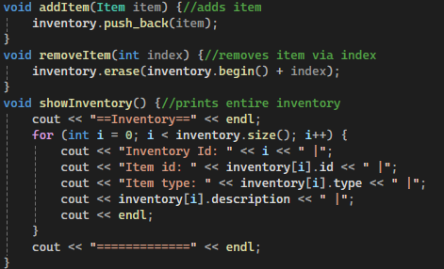

Testing was next, with it being very simple to do with all the functions and constructors I had made already. This is the demonstration part of the second goal

Testing:

Messed up my last commit slightly as I deselected some lines by accident.